UNDESA FEDERATED SEARCH APPLICATION
UNDESA CROSSWALK

INTRODUCTION
The UNDESA Crosswalk application, hereinafter called tochi, is a federated search application designed to ease the task of information discovery and extraction from multiple information repositories. One might ask the need for such an application when there are numerous search engines like Google; the answer is simple, due to the specificity of the information, tailor-made solutions like the crosswalk offer higher information discovery efficiency than generic solutions.

INSTALLATION INSTRUCTIONS
Presently, there is no release of tochi available, but one will be available with time. The following are the installation instructions; they assume basic knowledge of the Linux Operating System (in particular Ubuntu) but the instructions can be used on other systems as well.

REQUIRED LIBRARIES
Tochi requires certain libraries be available for successful compilation and deployment. These are
- Spring.jar (2.5+)
- spring-webmvc.jar (2.5+)
- spring-aspects.jar
- commons-collection.jar
- commons-logging.jar
- commons-fileupload.jar
- commons-lang.jar
- httpclient.jar
- dspace-api.jar
- dspace-api-lang.jar
- dspace-api-jspui.jar
- abdera-0.4-incubating.jar
- abdera-client-0.4-incubating.jar
- abdera-core-0.4-incubating.jar
- abdera-extensions-main-0.4-incubating.jar
- abdera-extensions-opensearch-0.4-incubating.jar
- abdera-parser-0.4-incubating.jar
- abdera-server-0.4-incubating.jar
- activation.jar
- handle.jar
- xpp3_min.jar
- xercesImpl.jar
- xstream.jar (3+)
- flexjson.jar
- jaxen.jar
- dom4j.jar
- log4j.jar
- mets.jar
- mail.jar
- marc4j.jar
- lucene-core-2.3.jar
- lucene-analyzers-2.3.jar
- poi.jar
- pdfbox.jar
- postgresql-8.1.jar
- tm-extractors.jar
- axiom-api.jar
- axiom-impl.jar
- jdom.jar
- htmlparser.jar
- jempbox.jar
- servlet-api-2.5.jar
- xalan-2.7.jar
- cglib-nodep.jar
- aspectjrt.jar
- aspectjweaver.jar
- normalizer.jar
- jstl.jar
- slf4j-api.jar
- slf4j-log4j.jar
- standard.jar
- ezmorph.jar
- xwork.jar
- xmlsec.jar

Most of these libraries are required by DSPACE as a DSPACE instance is executed within tochi.

Instructions:

- Install Java JDK 1.5+ and set the JDK_HOME to point to the Java installation directory. This can be done with the apt-get command from a terminal

$sudo apt-get install openjdk-6-jdk

Then, set the JDK_HOME environment variable by:
    - Open the file .bashrc in your home directory with your preferred editor
    - Append the line:
export JDK_HOME=/usr/lib/jvm/java-6-openjdk
    - Save the file
- Obtain the Java development tool ANT from the Apache website i.e. http://ant.apache.org version 1.6 and above.
1. Extract the archive to a folder
2. Edit the .bashrc file as in above

3. append the lines:
      - export ANT_HOME={extraction folder}
      - export PATH=$PATH:$ANT_HOME/bin
      - Save the file
- Get apache Tomcat 6+ (or any servlet 2.5 complient Java Application server like Mortbay Jetty 6) from the apache website i.e. http://tomcat.apache.org. Extract the archive into a folder, which we will designate as TOMCAT_HOME. The TOMCAT_HOME environment variable MUST be set.
- Obtain and install DSPACE 1.5+ digital repository. Be sure to note the DSPACE_HOME environment variable i.e. the location of the Dspace installation, this environment variable DSPACE_HOME MUST be set. The Dspace installation directory MUST be in the same server that is to house tochi.
- (Optional) Obtain and install Koha 3+ library application. Be sure to specify ZEBRA as the indexing option and enable the PazPar2 option during Koha configuration. This allows for remote access of the index server
- Checkout the tochi source from the google code svn repository.
svn co http://code.google.com/p/bungeni-dspace/trunk.
- From the tochi folder (designated as TOCHI_HOME), build tochi
$ant
- Modify the dspace configuration file DSPACE_HOME/config/dspace.cfg as follows:
In the Search indexing settings section, replace the <search.index.*> parameters with the following:
search.index.1 = author:dc.contributor.*
search.index.2 = author:dc.creator.*
search.index.3 = title:dc.title
search.index.4 = keyword:dc.subject.*
search.index.5 = abstract:dc.description.abstract
search.index.6 = author:dc.description.statementofresponsibility
search.index.7 = series:dc.relation.ispartofseries
search.index.8 = abstract:dc.description.tableofcontents
search.index.9 = mime:dc.format.mimetype
search.index.10 = sponsor:dc.description.sponsorship
search.index.11 = govdocument:dc.identifier.govdoc
search.index.12 = language:dc.language.iso
search.index.13 = description:dc.description
search.index.14 = issue_date:dc.date.issued

Also, search for the occurance of the parameter search.operator and replace the value to AND i.e. search.operator = OR to search.operator = AND

Re-index the index. This is done by executing the following command in DSPACE_HOME/bin

$DSPACE_HOME/bin/index-init

During re-indexing, make sure no instance of DSPACE is running.
Make sure this command is run as the user account that will deploy DSPACE!

CONFIGURATION

Managing Repositories
Repositories information is kept in an XML file called repositories.xml located in TOCHI_HOME/WEB-INF folder. Adding or removing repositories to be searched is just a matter of adding/removing lines in this file and restarting the application.

The following is the structure of the repositories.xml file:
<repositories>
<repository url="http://127.0.0.1:8080/crosswalk" family="dspace" default="true"/>
<repository url="http://127.0.0.1:11001/biblios" family="koha"/>
</repositories>

Managing Languages
Tochi is i18n enabled allowing it to be translated into several languages
Adding languages
Language records are kept in an XML file called languages.xml. Each entry in this file corresponds to a distinct language. In addition, there is a properties file with the structure messages_{language_code}.properties e.g. messages_en.properties for the English bundle. These properties files are located in TOCHI_HOME/WEB-INF/classes folder and contains the translations for the languages. The language code suffix of the properties files MUST correspond to the code attribute of the language tag of the appropriate language in languages.xml file. There is also a provision for the flags of the countries which speak the language. These flags are to be stored in the TOCHI_HOME/images/languages folder with the name being the code of the language and having the extension .png.

Language selection

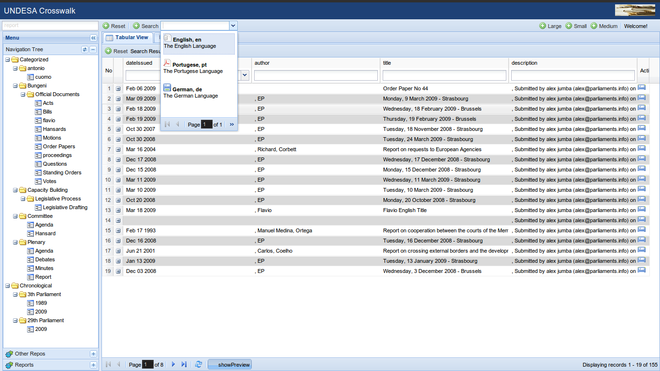
USAGE
Tochi can be used both as a web–service as well as a web application.
As a Web-Application
Tochi can be accessed in a browser by pointing the browser to the url: http://<hostname>:8080/crosswalk/. The top pane is the application banner as well as the master search controls and view mode controls.

The left pane houses an accordion which aids in the selection of the activities to be performed.

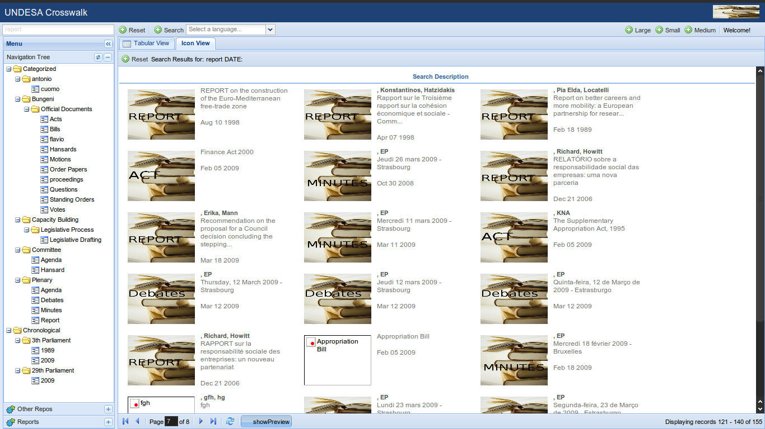

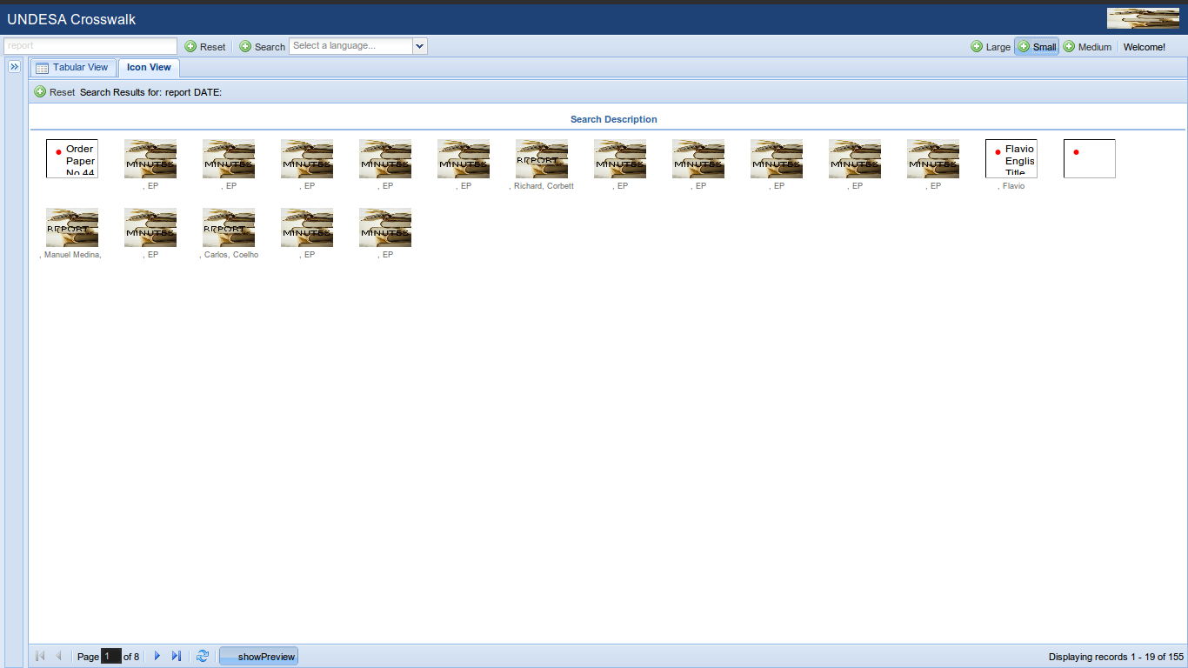
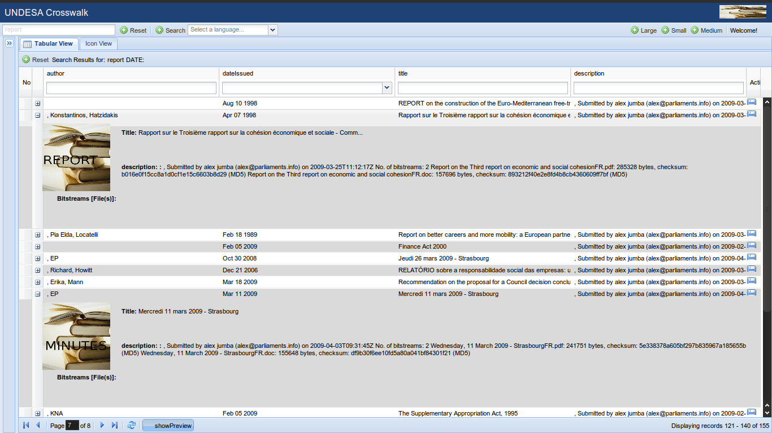

What parts of the url mean
The master base url does not change with the interactions of the user with the application. GET parameters are used to further customize the user experience. The following are the parameters:

lang: this specifies the language code of the language you would like to switch to e.g. pt for Portuguese
search: this is the search term to be searched by the application. This is a convenience parameter as the resulting page will contain the results of this search.

Navigation
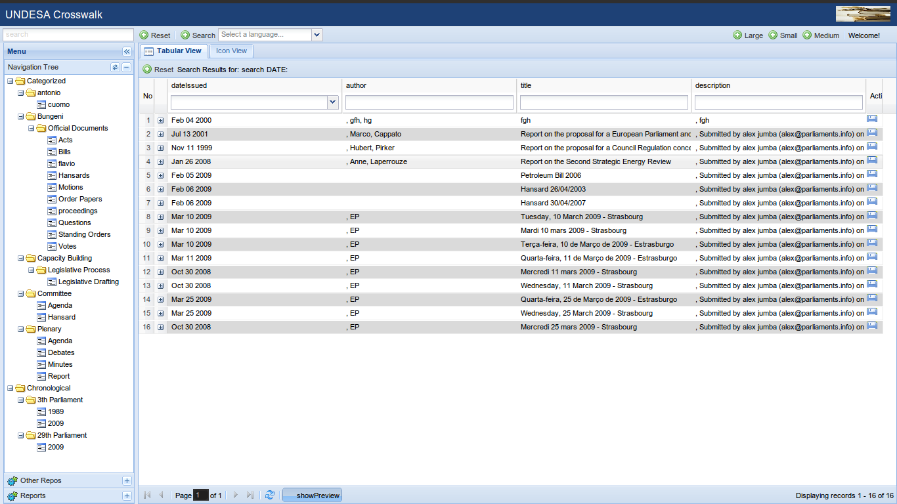

View Management
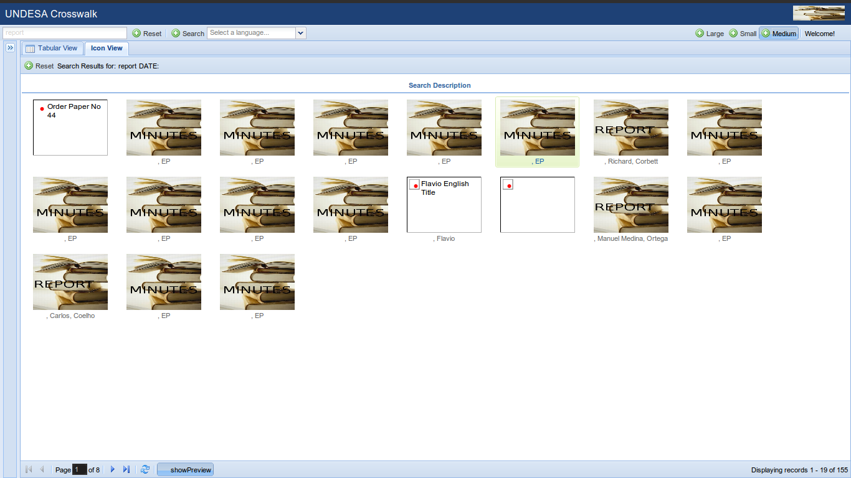

Reports
A reporting facility exists for the primary Dspace library managed by tochi. The reports are pluggable by the use of an XML file to specify the details of the reports and these reports will dynamically appear in the web user interface in the reports page. Tochi contains plugins to the dspace library that enable it to perform unique statistical analyses of the library items and relay this information to the reports exected by the reporting engine runtime.

The following is the structure of the reports.xml file located in the TOCHI_HOME/WEB-INF/ folder:
<reports>
<report name="Parliament Count" description="Report on Publications per parliament" uri="http://127.0.0.1:8080/report/frameset?__report=reports/parliament_count.rptdesign&amp;__format=pdf"/>
<report name="Repository Items" description="Report on Items available in the Repository" uri="http://127.0.0.1:8080/report/frameset?__report=reports/dspaceitems.rptdesign&amp;__format=pdf"/>
</reports>

The reporting page is as follows:

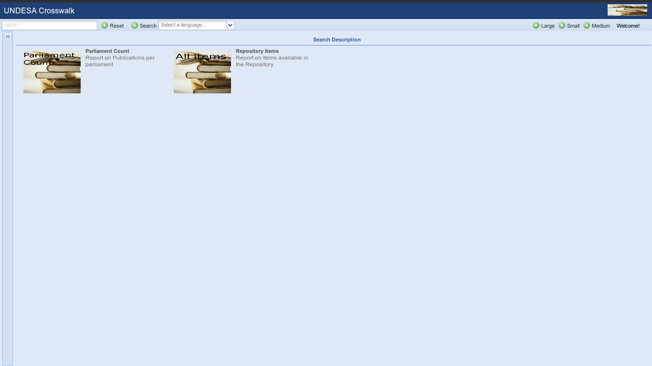

Tochi comes with several built-in reports. These are:
Report on Publications per parliament

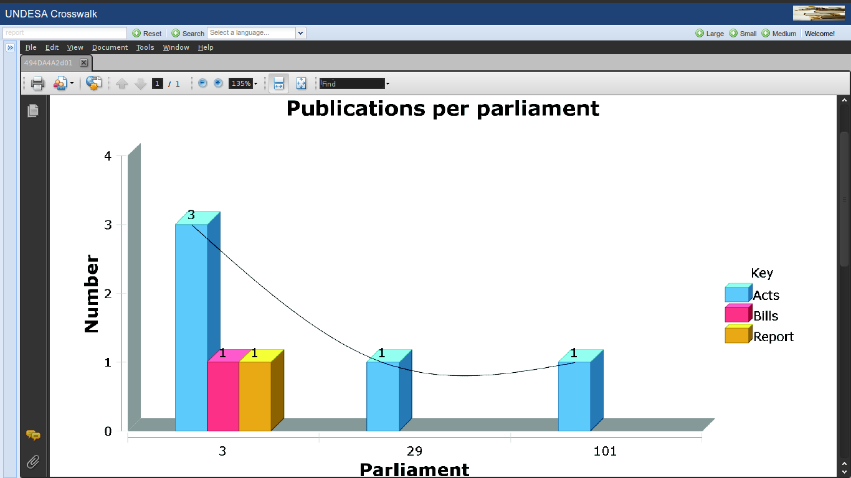
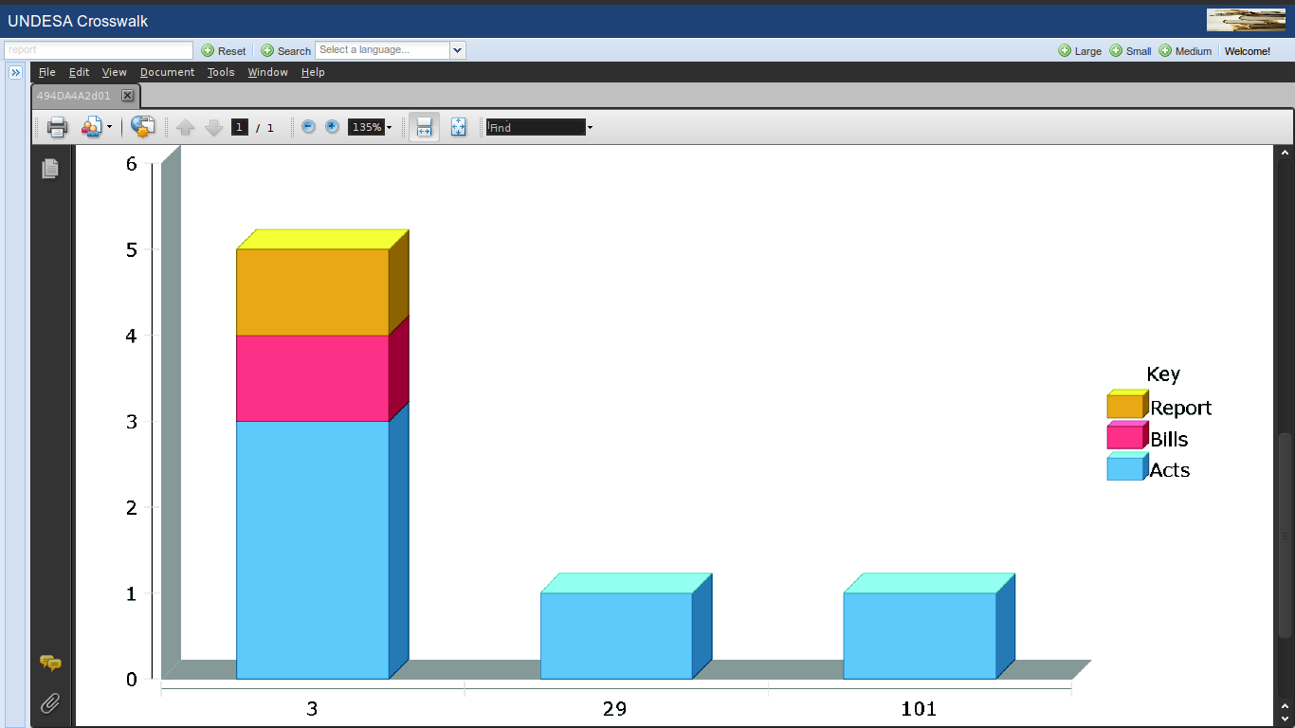

Report on items available in the repository

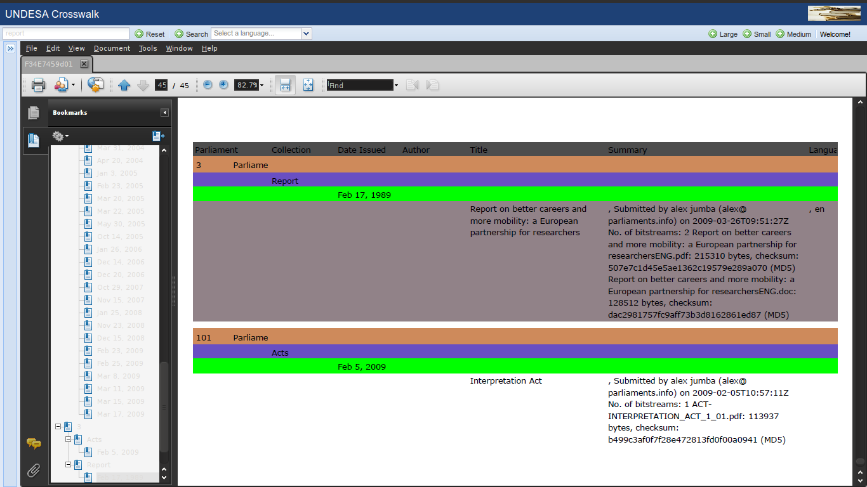

As aWeb-Service
Tochi exposes several web-services that offer convinience to developers as a standard API for accessing tochi services without a user interface. The following are some of the web-services exposed:

- Tochi search
- Automatic Item submission into Dspace library
- Reporting functions

We'll go into details of each.
- Tochi search
This web-service leverages the opensearch API as well as Atom feeds, viewable by an Atom 1.0 compatible feed viewer as well as select browsers (Mozilla Firefox 2.0+). The following is the structure of the web-service url:

Input
/bungeni-opensearch?pagesize={page_size}&start={starting_offset}&field1=ANY&query1={search_term}

Output:
[os output]

<feed xmlns="http://www.w3.org/2005/Atom" xmlns:os="http://a9.com/-/spec/opensearch/1.1/">
<os:itemsPerPage>10</os:itemsPerPage>
<os:startIndex>0</os:startIndex>
<os:totalResults>136</os:totalResults>
<id>tag:alex.org,2007:/foo</id>
<title type="text">Test Feed</title>
<subtitle type="text">Feed subtitle</subtitle>
<updated>2009-07-13T14:23:28.758Z</updated>
<author><name>Alex Jumba</name></author>
<link href="http://alex.com" />
<link href="http://alex.com/foo" rel="self" />
<entry>
<published>2009-02-06T10:36:52.493Z</published>
<title type="text">Hansard 24/02/2004</title>
<summary type="text">, Submitted by alex jumba (alex@parliaments.info) on 2009-02-06T10:36:52Z
No. of bitstreams: 1
Hansard 24-FEB-2004.doc: 251392 bytes, checksum: be68e121adcd84b50aaebbc6c1aec4a5 (MD5) </summary>
<id>123456789/48</id>
<content type="xhtml">
<div xmlns="http://www.w3.org/1999/xhtml">
<div>
<dl class="xoxo">
<dt />
<h1 />
<dt />
<h2>Hansards</h2>
<dt />
<h3>
<ul class="bitstreams">
<li>
<a target="_blank" href="/crosswalk/bitstream/123456789/48/1/Hansard%2024-FEB-2004.doc">Hansard 24-FEB-2004.doc 245.5 kB Microsoft Word</a>
</li>
</ul>
</h3>
</dl>
</div>
</div>
</content>
</entry>
<entry xml:lang=", en ">
. . . . . .
</entry>
. . . . . .
</feed>

- Automatic Item submission
url: /crosswalk/bungeni-alternate
This is a simple HTTP POST to the above url with the following parameters:
collection: the collection in which the item will belong
eperson: the eperson responsible for the item import
dublin_core: the item metadata in the form of an xml file. Structure will be elaborated
[binary files]: the bitstream files associated with the item. Can be multiple.

- Reporting functions
url: multiple as at now, will be coalesced in future.

Ubiquitous search
Tochi utilizes the opensearch protocols for universal searching across applications. The most visible advantage of leveraging the opensearch interface is the ability to perform a tochi search straight from the browser search box (Mozilla Firefox 2.0+, Microsoft Internet Explorer 7+).

Configuring browser search

Mozilla Firefox:
<During Development>
Execute the following line in the terminal:
$sudo cp TOCHI_HOME/war/os.xml /usr/lib/firefox-3.5.1pre/searchplugins

The path may vary depending on the desired firefox version.

<Deployment>
To register this service with firefox, the web application must be attached to a web domain

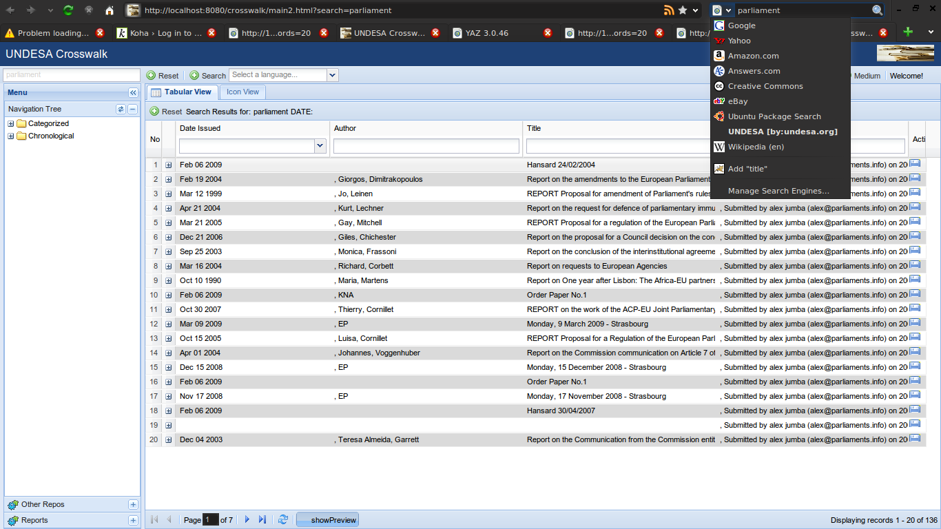

Restart Mozilla Firefox.
The Firefox search box will now contain the crosswalk search as shown above.

Changing Collection icons
Collection icons are stored in the TOCHI_HOME/images/collection directory. Below is a screenshot with some icons missing viz. Bill

